Photo Upload for Mac

- Go to www. http://filezilla-project.org/. Download FileZilla Client and install on your Mac. Double click the resulting download file. It will put FileZilla in your downloads folder. Drag it from there to your Applications Folder.
- Create a directory on your computer with a directory name of “Firstname Lastname”. So in my case it would be Gary Haynes. This will be the directory that will be on the Forum share site.
- Put the photos on your computer where you can find them. Best place is the directory you just created in step 2. JPG’s are fine. They don’t have to be very large, I usually use my photo editing software to generate them at 900 pixels on the long side at 72dpi. Experiment with one to see what you like.
- Start FileZilla
- Click on File and select Site Manager from the toolbar
- Click New Site
- 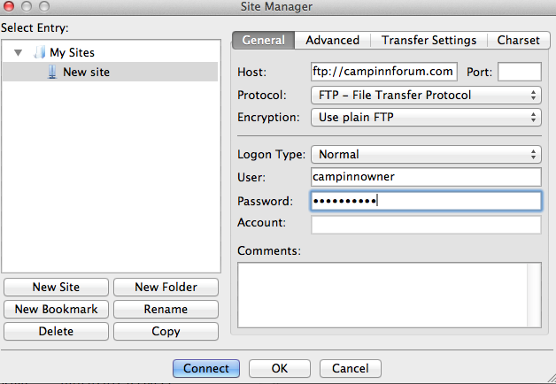
- Fill in the blanks as shown. Password is #4#thebest.
- Save the entry by clicking OK. You can highlight it and click rename to something you want.
- Click Connect. If you leave and come back go to File – Site Manager and pick your connection.
- Click on Connect to connect to the FTP site
- You will see a screen that looks like this.
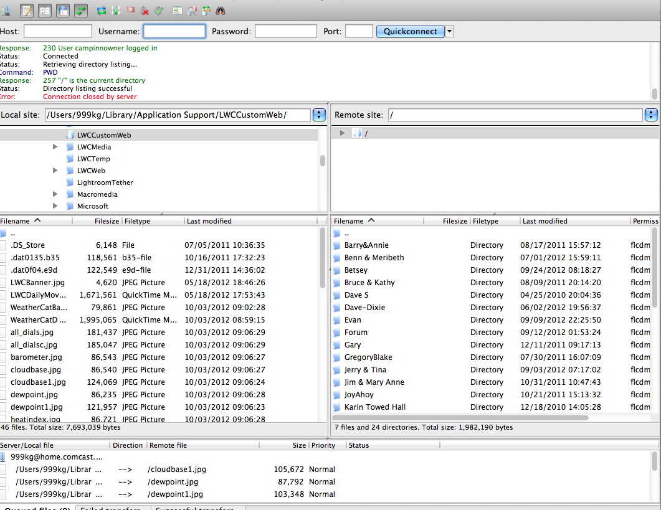
- The left section is your computer and the right hand side is the share site where photos are stored.
- On the left hand side look in the section labeled “Local Site” and find the directory that you have created that contains your photos.
- Right click on the Right hand side and pick Create Directory.
- Type a name for your directory and click ok.
- Now that the directory is created simply go to the folder where you have your photos located and drag and drop them into your new directory on the share site.
- On the right hand side “Remote Site” section scroll to the bottom so that you see a section that has individual files. Drag the file folder you created in Step 2 which contains your photos to the right hand side, dropping it into the area that has the individual files listed.
- Your file folder should now be on the Remote site list. Scroll up to see it.
- If you want to add more photos in the future you will only need to drag and drop the individual photos into your folder. No need to re-create the folder again.
- Final steps are to put the photo in your post. Click the following link http://www.campinnforum.com/ubbthreads/userftp/
- Go and open your directory.
- Right click on the image you want to use and select “Copy Link Address”.
- Create the new post. There is a picture icon that looks like 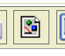 this on the top of the post creation. Select how you want to have the photo located. In the resulting popup box paste in the link you copied on the previous step. Result will look like:
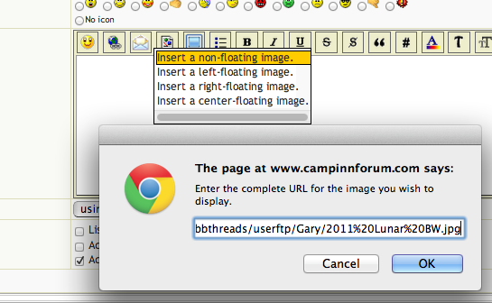

Click OK.

19. Repeat as needed in your post.
20. Click Preview to see what it looks like.

